Implement Client Script & UI Policy (Incident)
Phase 6: Project Documentation
Item | Details
Project Name | Implement Client Script & UI Policy (Incident)
Platform | ServiceNow
Target Table | Incident [incident]
Team ID | SWTID-2026-6974
Document Type | Solution overview, configuration guide, user guide and test record

1. Project Overview

1.1 Purpose
Incident records need consistent and accurate data for triage, routing, SLA tracking and reporting. Relying on user awareness alone leads to incomplete or inconsistent records. This project enforces the rules at the user interface level with a UI Policy and Client Scripts, so records meet the business rules before they are submitted.

1.2 Scope
- In scope: the Incident form and the Incident list view in the desktop UI of ServiceNow.
- Out of scope: API, import and other server-side updates, and tables other than Incident.

1.3 Skills Demonstrated
Incident Management, UI Policy, UI Policy Actions, Client Scripts and Form Validation.

2. Solution Summary

2.1 Business Rules
ID | Business Rule
BR1 | When Impact is 1 - High, Assignment group must be provided.
BR2 | When Impact is 1 - High, Urgency is set to High and cannot be edited.
BR3 | When Impact is 1 - High, an incident cannot be saved unless Assigned to is filled in.
BR4 | When Impact is no longer High, the restrictions applied by the UI Policy are reversed.
BR5 | State cannot be changed by editing in the list view; it is changed on the Incident form.

2.2 Components and Traceability
Component | Type | What It Does | Rule
High Impact Control | UI Policy | Applies when Impact is 1 - High and reverses when it is not | BR1, BR4
Assignment group action | UI Policy Action | Sets Assignment group to Mandatory | BR1
Urgency action | UI Policy Action | Sets Urgency to Read only | BR2
Auto set urgency for high impact | onChange Client Script | Sets Urgency to 1 (High) and shows a message when Impact changes to High | BR2
Prevent save if Assigned To missing | onSubmit Client Script | Blocks the save and shows an error on Assigned to | BR3
Prevent state change via list edit | onCellEdit Client Script | Shows an alert and cancels the State edit in the list | BR5

2.3 Incident Fields Used
Label | Field Name | Type | Used By
Impact | impact | Choice | UI Policy condition, onChange, onSubmit
Urgency | urgency | Choice | UI Policy Action, onChange
Assignment group | assignment_group | Reference | UI Policy Action
Assigned to | assigned_to | Reference | onSubmit
State | state | Choice | onCellEdit

3. Configuration Guide
Log in to the instance with administrative or configuration access before starting.

3.1 Create the UI Policy
- Go to System UI → UI Policies and click New.
- Set Table to Incident, the Short description to High Impact Control, and Active to true.
- Under When to Apply, set the condition Impact is 1 - High.
- Check Reverse if false so the policy undoes its changes when the condition is not met.
- Click Submit.
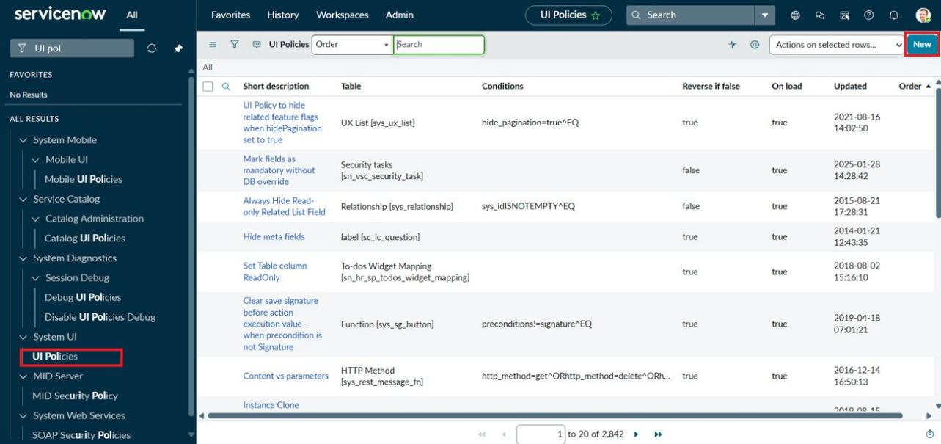
Figure 1: UI Policies list with the New button
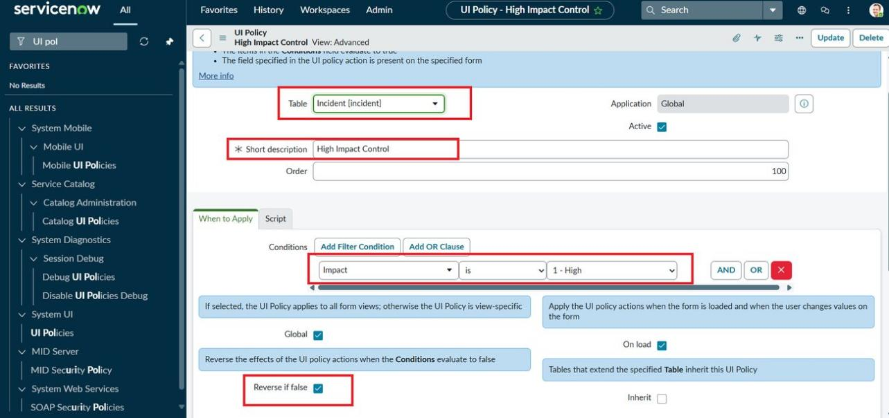
Figure 2: High Impact Control UI Policy on the Incident table

3.2 Add the UI Policy Actions
- In the High Impact Control policy, open the UI Policy Actions related list and click New.
- For the first action, set Field name to Assignment group and Mandatory to True.
- For the second action, set Field name to Urgency, Read only to True and leave Visible as Leave alone.
- Click Submit for each action.
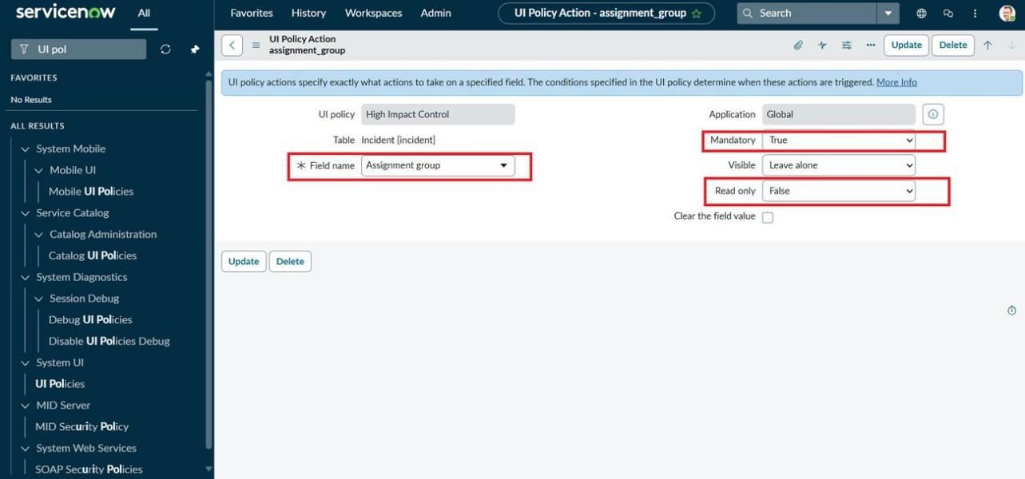
Figure 3: UI Policy Action: Assignment group is Mandatory
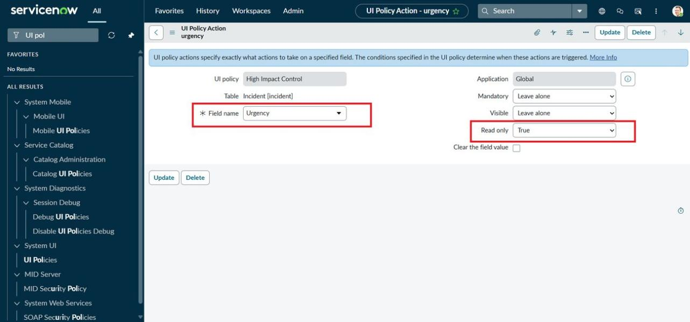
Figure 4: UI Policy Action: Urgency is Read only

3.3 Create the Client Scripts
Go to System UI → Client Scripts, click New, and create the three scripts below. All three use Table = Incident, UI Type = Desktop and Active = true.
Name | Type | Field name | Purpose
Auto set urgency for high impact | onChange | Impact | Set Urgency to High when Impact becomes High
Prevent save if Assigned To missing | onSubmit | Not used | Block the save when Assigned to is empty for High impact
Prevent state change via list edit | onCellEdit | State | Cancel State edits made in the list
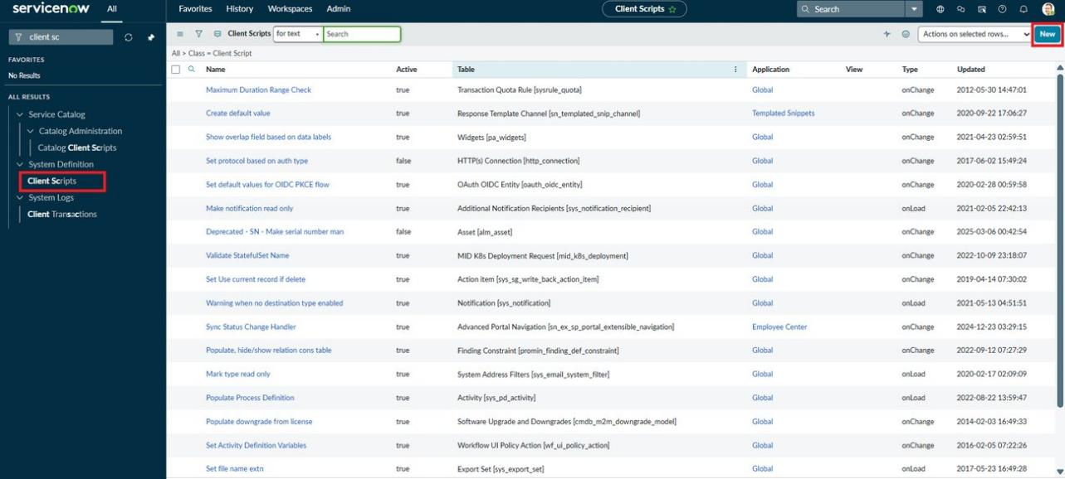
Figure 5: Client Scripts list with the New button
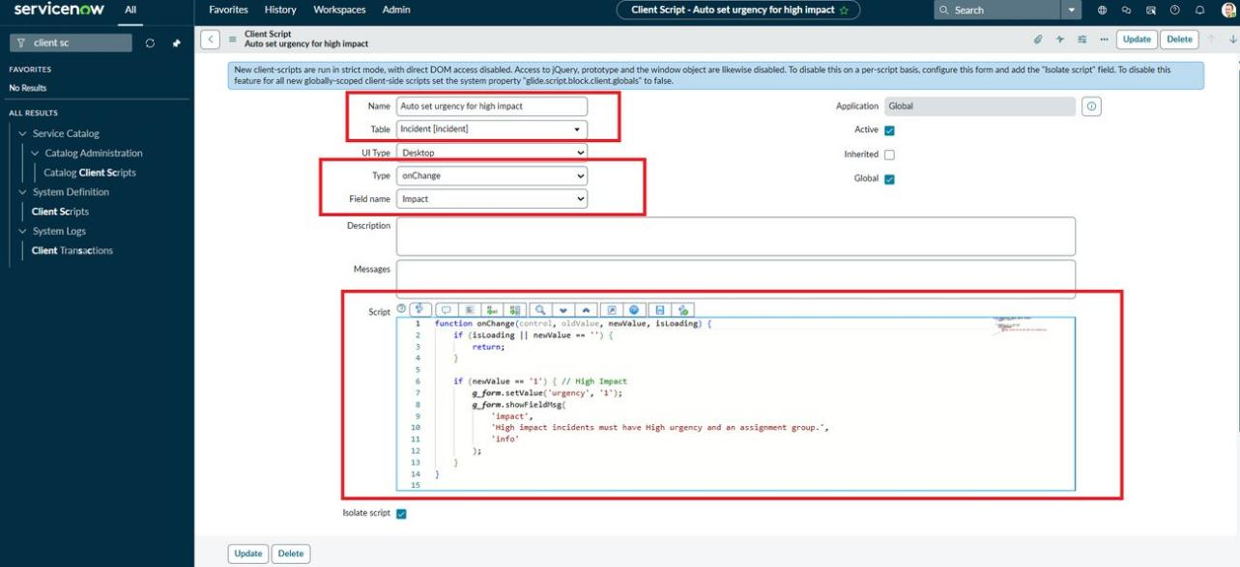
Figure 6: onChange script: Auto set urgency for high impact
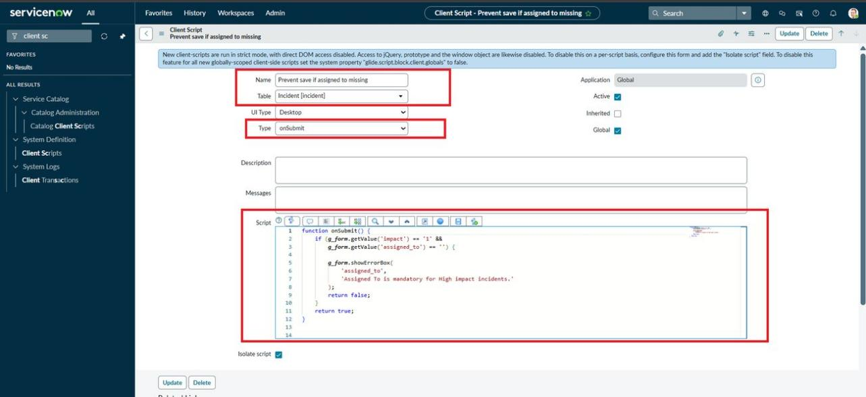
Figure 7: onSubmit script: Prevent save if Assigned To missing
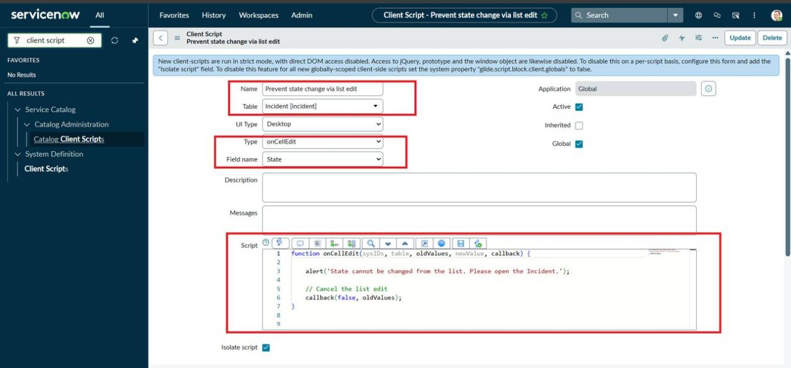
Figure 8: onCellEdit script: Prevent state change via list edit

3.4 Script Reference
onChange (Impact)
function onChange(control, oldValue, newValue, isLoading) {
if (isLoading || newValue == '') {
return;
}
if (newValue == '1') {
g_form.setValue('urgency', '1');
g_form.addInfoMessage('Urgency set to High for High impact incident.');
}
}

onSubmit
function onSubmit() {
if (g_form.getValue('impact') == '1' &&
g_form.getValue('assigned_to') == '') {
g_form.showErrorBox(
'assigned_to',
'Assigned To is mandatory for High impact incidents.'
);
return false;
}
return true;
}

onCellEdit (State)
function onCellEdit(sysIDs, table, oldValues, newValue, callback) {
alert('State cannot be changed from the list. Please open the Incident.');
callback(false, oldValues);
}

The guide gives two versions of the onChange and onCellEdit scripts (text and screenshot). This document uses the text version for onChange and the screenshot version for onCellEdit.

4. User Guide
This section describes what an agent sees when working with Incident records.
When the User... | The System... | Rule
Sets Impact to 1 - High | Makes Assignment group mandatory, sets Urgency to High, makes Urgency read-only and shows an information message | BR1, BR2
Clicks Submit with Assigned to empty (Impact High) | Blocks the save and shows "Assigned To is mandatory for High impact incidents." under Assigned to | BR3
Fills in Assigned to and clicks Submit | Saves the incident | BR3
Changes Impact from High to another value | Removes the mandatory and read-only settings so the fields can be edited again | BR4
Double-clicks State in the list view | Shows an alert and keeps the State value unchanged | BR5
Changes State on the Incident form and clicks Update | Saves the change | BR5

5. Testing Record
The tests follow Task 6 of the project guide. The screenshots below show the observed behaviour.
No. | Test | Expected Result | Evidence
T1 | Save with Impact High and Assigned to empty | Save blocked with an error on Assigned to | Figure 9
T2 | Save with Assigned to filled | Incident saves without errors | Figure 10
T3 | Change Impact from High to Medium | Mandatory and read-only rules are removed | Figure 11
T4 | Edit State in the list view | Alert appears and State is unchanged | Figure 12
T5 | Change State on the form | State change saves | Figures 13 and 14

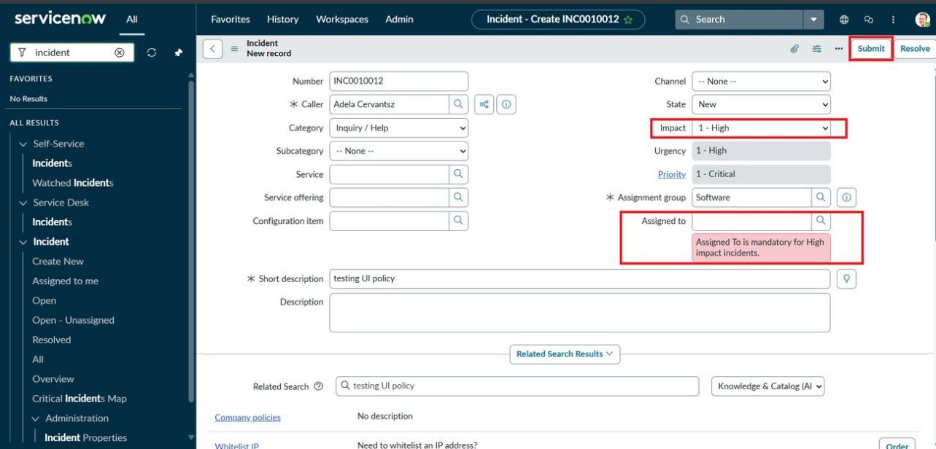
Figure 9: T1: Save blocked with an error on Assigned to
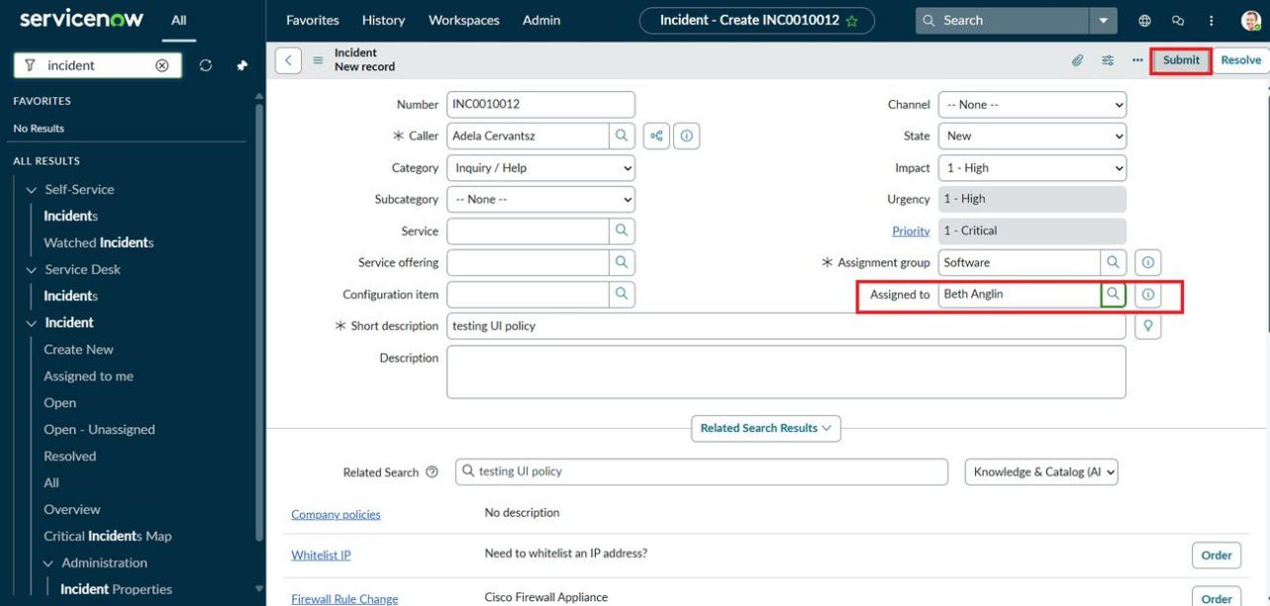
Figure 10: T2: Assigned to filled in, ready to submit
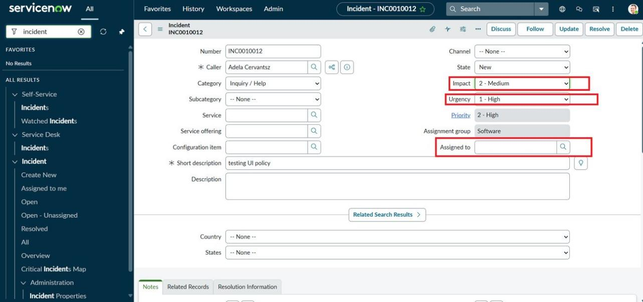
Figure 11: T3: Impact changed to 2 - Medium, Assigned to no longer required
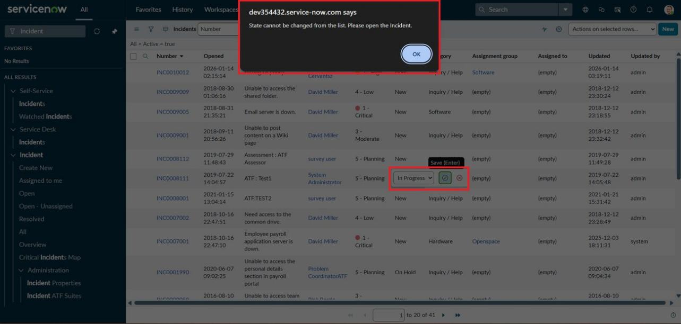
Figure 12: T4: Alert shown when State is edited in the list
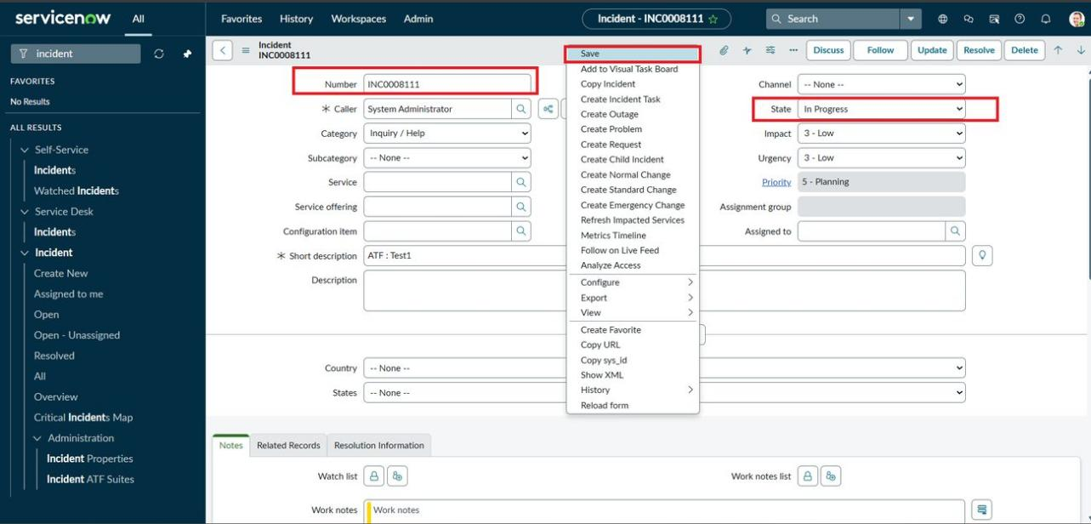
Figure 13: T5: State changed to In Progress on the form
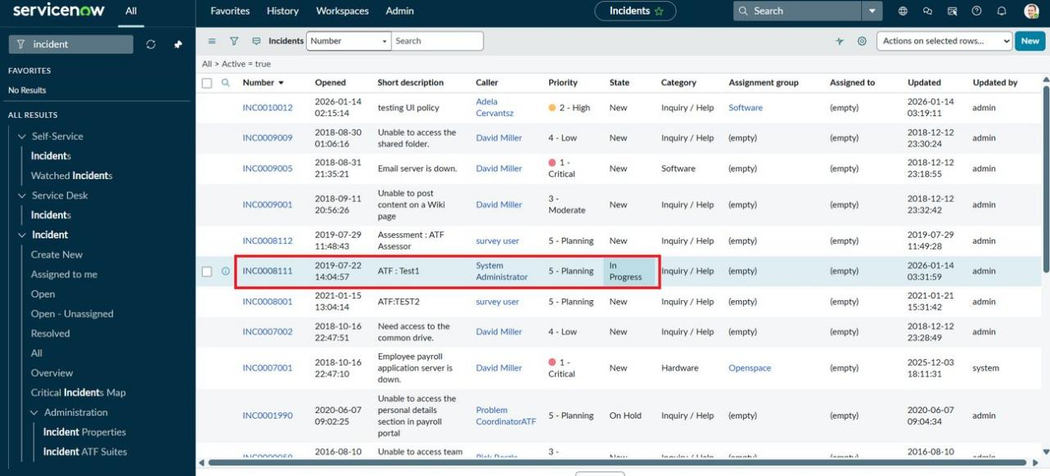
Figure 14: T5: List view showing the saved State

6. Known Limitations and Troubleshooting
Situation | Likely Cause | What to Check
Urgency stays at High after Impact is lowered | The onChange script sets Urgency only when Impact becomes High and does not reset it | Change Urgency by hand; the field is editable again after the reverse
Save is not blocked for a High impact incident | The onSubmit script is inactive, or the incident is updated through an API or import | Confirm the script is Active and that the update comes from the form
Assignment group is not mandatory | The UI Policy is inactive, Reverse if false is misconfigured, or the condition is wrong | Check Active and the condition Impact is 1 - High
State can be edited in the list without an alert | The onCellEdit script is inactive or the field name is not State | Check Active, Type onCellEdit and Field name State
Scripts do not run on a different UI | The scripts use UI Type Desktop | Create matching scripts for other UIs if they are needed

7. Maintenance and Future Enhancements
- Maintenance: keep every record Active and named as in Section 2.2, and change configuration only with administrative access.
- Server-side enforcement: add a Business Rule or Data Policy so the rules also apply to API and import updates.
- Urgency reset: set Urgency back to a default value when Impact is lowered.
- Consistent rules: decide whether Assignment group, Assigned to or both should be required, and align the UI Policy and the onSubmit script.

8. Conclusion
The project shows how a UI Policy and three Client Scripts work together to keep Incident data complete and consistent. The configuration is small, uses only standard ServiceNow features and was verified with five tests. This document records the design, setup, use and testing of the solution, so it can be repeated, maintained and extended.

